Viewing and Printing Images

Document Viewer Panel:
- Opens automatically in Indexing and Searching Workspaces.
- Displays scanned images and documents.
- Multi-page documents will display thumbnails for each page for easy selection.
- Document Viewer displays one page at a time in the full size viewer screen.
- The Open in New Window and View as PDF commands allow for multiple images to be open and displaying at the same time.

Document Viewer:
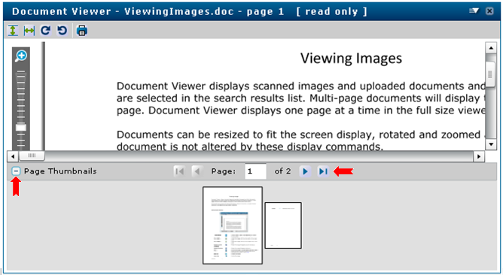

Documents can be resized to fit the screen display, rotated and zoomed as needed. Original document is not altered by these display commands.

Thumbnail display can be closed or opened using the control button. or

Print Document:
- Click drop down Menu button. See screen shot below.

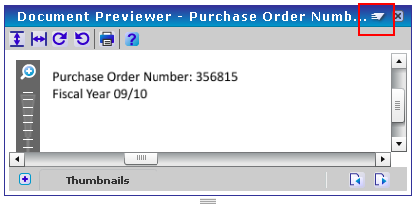

- Click Open as PDF. See screen shot below.

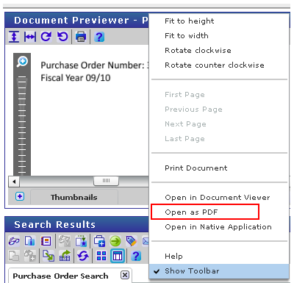

- In PDF window use the Print command.

Document Viewer Buttons and Commands:

Panel Menu |  |  | Viewer options. Options vary depending on a user's Feature Rights.
 | Fit to Width |  | Adjust the image to fill the entire width of the viewer pane.
 | Fit to Height |  | Adjust the image to fill the entire height of the viewer pane.
 | Rotate Counter Clockwise |  | Rotate the image 90 degrees counter-clockwise.
 | Rotate Clockwise |  | Rotate the image 90 degrees clockwise.
 | Zoom In |  | Magnify the image.
 | Zoom Out |  | Shrink the image.
 | Thumbnails | / | Toggle display of thumbnail of document.

