Searching for Images in v10

Following are the steps to search for images in Docfinity version 10.

Searching for Images:

- Log into Docfinity
- Open Searching Workspace in Welcome screen.

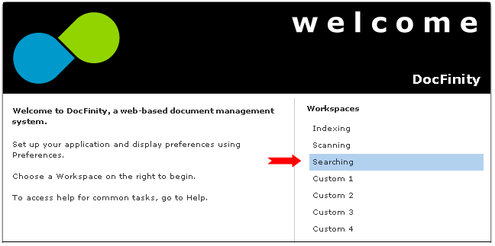

- Searching Workspace includes Panels for: Search Panel, Document Viewer and Search Results Panel.

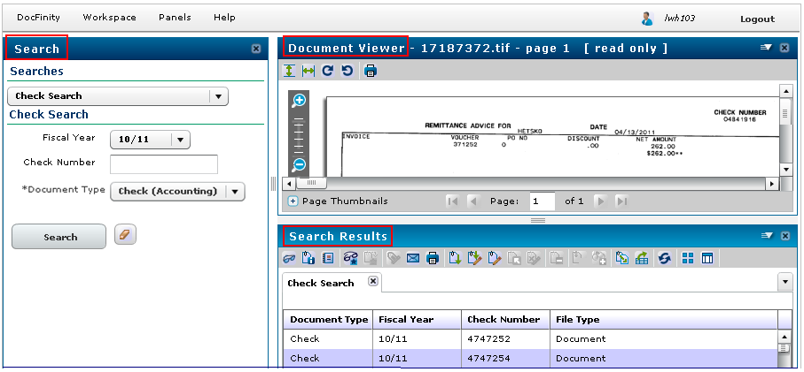
Search Panel: Searches
- Search field contains the list of customized searches available.
- Click drop down arrow in search field.
- Select the search for the document type needed.

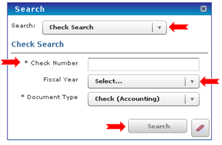

- Search name and the Metadata fields for each document type will display. An Asterisk * denotes required metadata. Data must be selected or entered in this field for the search to be completed.
- Click Search.

Search Results Panel:
- All documents matching the search criteria will display in the Search Results screen.
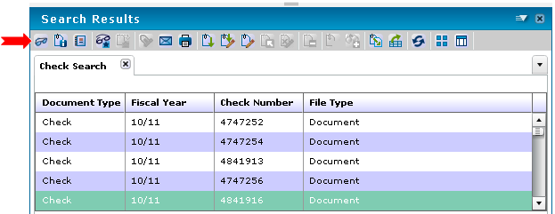
- To view a document double click it or click it once and click the View Document icon
- Document will display in Document Viewer Panel. See details on next page.
- Each new search completed will be displayed in a new tab in the Search Results screen making it easy to go back to a prior search with just a click. See screen shot below.

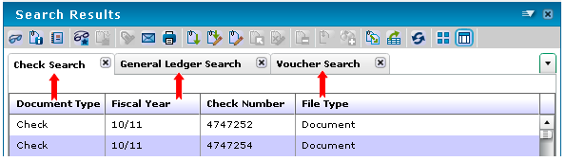
- Click here for additional details on the Search Results Button Bar and drop down menu.
- When Panel is closed all search results are cleared.

Additional Searching Details:
- When opened the Search Panel displays the last search and last prompt values entered.
- Searches are designed and assigned to users by administrators.
- Requests for new searches or access to additional searches are submitted to PSU DocFinity Support.

Logging out:
Click the Logout button in the upper right corner of the screen to end your session in DocFinity.
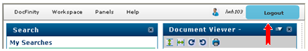

Document Viewer Panel:
- Button Bar and the Drop Down Menu commands allow user to control view.
- Multipage documents are viewed one page at a time. The page control fields allow movement between pages.
- Thumbnail viewing area is opened or closed using the or buttons.
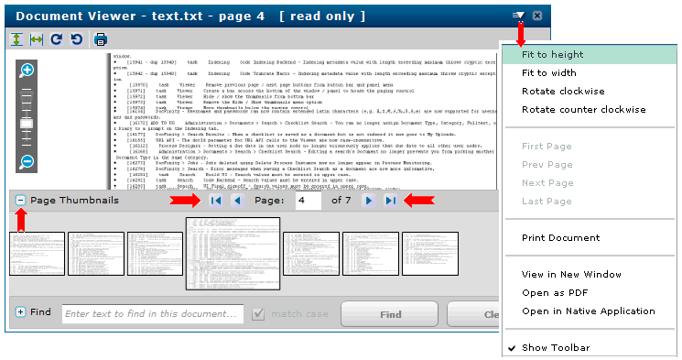

- When Document Viewer Panel is closed document display is cleared. Documents viewed in separate tab or as a PDF remain displayed in browser tabs.

Document Viewer Panel - Buttons and Commands:

Panel Menu |  |  |  |  |  |  |  |  |  | Viewer options. Options vary depending on a user's Feature Rights.
 | Fit to Width |  |  |  |  |  |  |  |  | Adjust the image to fill the entire width of the viewer pane.
 | Fit to Height |  |  |  |  |  |  |  |  | Adjust the image to fill the entire height of the viewer pane.
 | Rotate Counter Clockwise |  |  |  |  |  |  |  |  | Rotate the image 90 degrees counter-clockwise.
 | Rotate Clockwise |  |  |  |  |  |  |  |  | Rotate the image 90 degrees clockwise.
 | Print |  |  |  |  |  |  |  |  | Print the document. Printing requires the Print Feature Right and View document security access to the document to be printed. Opens Print.
 | Zoom In |  |  |  |  |  |  |  |  | Magnify the image.
 | Zoom Out |  |  |  |  |  |  |  |  | Shrink the image.
 | View in New Window |  |  |  |  |  |  |  |  | Open the displayed document in the full Document Viewer (which allows markups and annotations) in a new browser window. Requires View document security access to the document.
 | Open as PDF Document |  |  |  |  |  |  |  |  | Open the displayed document as a PDF. The workstation must have the ability to open and display PDFs. Requires View document security access to the document to be opened.
 | Open as Native Document |  |  |  |  |  |  |  |  | Open the displayed document in the document's native program. The workstation must have the native program installed. Requires View document security access to the document to be opened. The native application must be available on the local workstation.
 | Show Toolbar |  |  |  |  |  |  |  |  | Toggle the display of the image control buttons. Default is "Show".
Zoomer Bar |  |  |  |  |  |  |  |  |  | Magnify or shrink the image. Click the bar to magnify to that level.
 |  |  |  |  |  |  |  |  |  | Magnify the image.
 |  |  |  |  |  |  |  |  |  | Shrink the image.
Canvas – Displays the image. Right-clicking displays a context-sensitive menu.
Scroll Bar – Scrolls the image. You can also use a mouse scroll-wheel to scroll the image.
Page Thumbnails – Displays up to ten individual pages in a multi-page document at a time, as thumbnails. Click a thumbnail to select that page and display it in the Document Preview panel.
/ |  |  |  |  |  | Toggle the thumbnail display.
First Page |  |  |  |  |  | Go to first page of document.
Previous Page |  |  |  |  |  |  |  | Go back one page.
Page |  |  |  |  |  |  |  | The current page. Type in page number and hit enter to display that page.
Next Page |  |  |  |  |  |  |  | Go forward one page.
Last Page |  |  |  |  |  |  |  | Go to last page of document.

Search Results Panel – Buttons and Commands

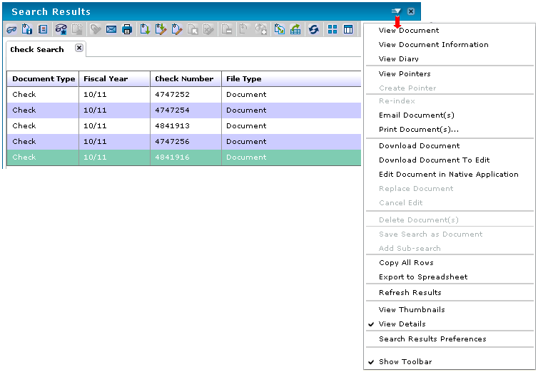

Panel Menu |  |  |  | Search Results options. Some options appear only if the user has the appropriate Feature Rights and the search type supports that function.
 | View Document |  |  | Open the document in Document Viewer, or if the document is a saved Checklist Search, opens the saved checklist in a Search Results tab. Not available when multiple documents are selected.
 | View Document Information |  |  | View the selected document's metadata and footnotes, if any. Opens the Document Information panel. Not available when multiple documents are selected.
 | View Diary… |  |  | View the selected document's diary. Opens the Diary panel. Not available when multiple documents are selected.
 | View Pointers |  |  | View all pointers for the selected document. Pointers are copies of a document that may have different metadata than the original. Not available when multiple documents are selected.
 | Create Pointer |  |  | Create a pointer to the document. Opens the Index panel to provide pointer metadata. Requires the Create Pointer and Index Feature Right and Update and View document security access to the document. Not available when multiple documents are selected.
 | Re-index |  |  | Edit the metadata associated with the selected document. Opens the Index panel. Requires the Reindex Feature Right and Update document security access to the document. Not available when multiple documents are selected.
 | Email Document |  |  | Email the selected document as an attachment or email a link to the document. Opens the Email Document window, where you can address an email. Requires the Email as Attachment Feature Right and View document security access to the document. If the document has redactions, override_redactions document security access is also required.
 | Print Document |  |  | Print the selected document(s), using server printing. Opens the Print window, where you can select a printer accessible to your group(s) and set any document options and cover sheets. Printing requires the Print Feature Right and View document security access to the document to be printed (override_redaction required to print a document without its redactions; view_markup to print with its markups).
 | Fax Document |  |  | Fax the selected document(s) using a fax service. Opens the Fax window. Faxing requires the Fax Feature Right and View document security access to the document to be faxed (override_redaction required to fax a document without its redactions; view_markup to fax with its markups).
 | Download Document |  |  | Download a copy of the selected document from the Repository. Opens a system Save File dialog. A confirmation message is displayed at the completion of the download. Requires Edit document security access. Not available when multiple documents are selected or when a form is selected.
 | Download to Edit |  |  | Download and check out the selected document from the Repository for editing. Once a document is checked out, no other user may edit it until it is checked back in using Replace Document or the edit is cancelled using Cancel Edit. Opens a system Save File dialog. A confirmation message is displayed at the completion of the download. Requires Edit document security access. Not available when multiple documents are selected or when a form is selected.
 | Edit Document in Native Application |  |  | Opens the document directly in its native application (the native application must be available to the workstation). Requires Edit document security access. Not available when multiple documents are selected.
 | Replace Document |  |  | Replace a document in the Repository. Opens Replace Document. Requires Edit document security access. Not available when multiple documents are selected or when a form is selected.  If the Document Type allows versioning (set in DocFinity Administration > Documents > Document Classification > Document Type), the original document remains in the Repository as an old version, and the original document’s metadata information is retained and attached to the new version.  If the Document Type does not allow versioning, the new document simply replaces the old document. The old document is overwritten and cannot be recovered.
 | Cancel Edit |  |  | Cancel the edit on the selected document and mark it as checked-in, allowing other users to check it out for editing. Requires Edit document security access. Not available when multiple documents are selected.
 | Delete Document |  |  | Delete the selected document from the Repository. Requires the Delete a Document Feature Right and Delete document security access to the document.
 | Copy All Rows |  |  | Copy the search results to the clipboard. Results are formatted in CSV format. Requires the Copy Results to Clipboard Feature Right.
 | Export to Spreadsheet |  |  | Export the results of a search to a CSV formatted file. The file is automatically emailed to you. However the results of the search have been sorted is how they will appear in the CSV file, except for Stored Procedure and Checklist Searches, which export in their default sort. The exported CSV file will contain all results found by the search, not just the first 2000 (the maximum amount that can be displayed in the Search Results window). Requires the Export to Spreadsheet feature right.
 | Refresh Results |  |  | Search again using the same search settings.
 | View Thumbnails / Switch to Thumbnail View |  |  | Display search results as thumbnail images.
 | View Details / Switch to Details View |  |  | 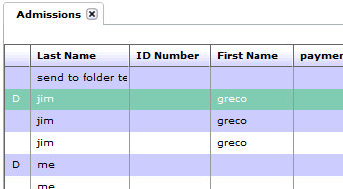  Display search results in columns (default). The columns include Last Name, First Name, Address, and File Type (which indicates if the file is a document or a form). Double-click on a column header to sort the results by that column, ascending or descending.  If the Flags column is enabled (DocFinity > Preferences > Search Results > Show Document Flags Column), the first (unlabelled) column displays a "P" if the document is a pointer, a "D" if the document has diary entries, and a “C” if the document is checked out for editing.
 | Show Toolbar |  |  | Toggle the display of the button bar. Default is "Show".

Return to Steps for Searching

