Indexing in DocFinity Version 10

The Indexing workspace lets you check out batches of documents, view documents, and enter metadata to identify images. Batches of scanned or uploaded files are indexed with the metadata required to be included in the searchable DocFinity database.

Begin Indexing:
- Open Indexing Workspace.
- In Batch Panel click on a Batch to select it to be Checked-out.
- Click Check-out button - . See screen shot below.

Note: A user can only check-out one batch at a time. A checked-out batch cannot be viewed or indexed by any other user while checked-out. The check-in process saves all entered metadata and releases the batch to be available to other users.

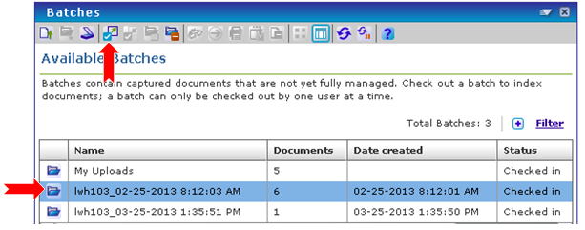

- Batch Panel displays. The screen shot below shows the thumbnail view of the image in the batch. Display can be changed to Details View by clicking the Details View button . Change to Thumbnail view by clicking the Thumbnail View button .

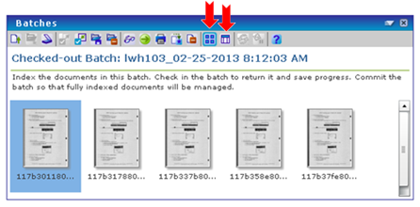

Document Viewer Panel:
- First image in batch will display in Document Viewer where it can be edited if needed.
- Any image in batch can be selected to be opened in Document Viewer.

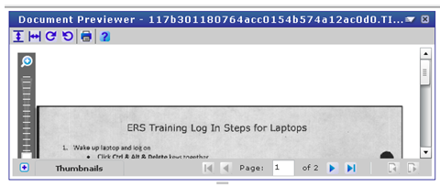

Index Panel:
- Index panel contains metadata fields to complete for the document selected.
- Metadata added during the scanning process will be displayed with all other metadata fields.
- Required metadata has an * to the left of field name.
- Enter or select as much metadata as is needed for each image. See screen shot below.

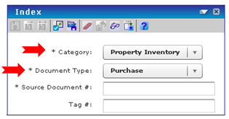

Indexing Actions:
- Metadata is entered for each image/document and Saved.
- There are functions that will assign metadata to a whole batch or to the rest of the batch that is open. or
- Saved metadata remains on the images/documents allowing Batches to be checked-in and checked –out as needed until all metadata is completed.
- Checking in a batch makes it available for other users to index. When checking in a batch, save any indexed metadata.
- Images/documents are not considered indexed until the batch is committed.

Committing Batch:
- Commit a Batch by clicking the Commit button.
- The commit process releases the image/document to the searchable database.
- Only images/documents with complete metadata will commit. Unfinished images/documents will remain in the batch.
- When all images/documents in a batch are committed the batch will disappear.

Pointers:
- A Pointer creates a virtual copy of the image/document, which is added to the batch for indexing.
- Pointers allow for a second set of metadata to be assigned to the image/document.
- Pointers make an image/document searchable on two sets of criteria.
Multiple pointers are possible for one image/document.

Deleting:
- Individual images/documents can be deleted.
- Entire Batches can also be deleted.
- Select image/document or batch and click the Delete button.

Setting Preferences:
- Select DocFinity Menu/ Preferences/ Indexing.
- Select options that streamline indexing process.
- Click Save.

Button Bar & Menu Items:

Panel Menu |  |  | Indexing options. Options vary depending on a user's Feature Rights.
 | Save Metadata |  | Save all metadata for all documents in the batch for future indexing.
 | Index Rest |  | Index the remaining documents in a batch with the metadata associated with the current document. Requires the Index Rest Feature Right.
 | Index All |  | Index all the documents in a batch with the metadata associated with the current document. Requires the Index All Documents Feature Right.
 | Check-in Current Batch |  | Check in the current batch so others may work with it. All metadata indexed is saved, but documents are not marked as indexed until a user commits the batch.

 | Commit Current Batch |  | Index the documents in the currently checked-out batch. Only documents that have a complete set of metadata (all required metadata) are indexed. Any remaining documents stay in the batch, which is automatically checked in, to be indexed later. If all documents in a batch are indexed, the batch is removed.
 | Delete Batch |  | Delete the selected batch from the system. This also deletes all documents in the batch. You are prompted to confirm the deletion.
 | Clear Document's Metadata |  | Clear user entered data and reset metadata field values to any default values for the current document. Requires the Unindex Documents Feature Right.
 | Reset to Document's Saved Metadata |  | Reset metadata field values to the last saved values for the current document.
 | View Document |  | Display the current document in Document Preview. Requires the View Document Security access to the document.
 | Create Pointer  View Thumbnails  View Details |  | Create a virtual copy of the current document, which is added to the batch for indexing. Requires the Create Pointer Feature Right and Update Document Security access to the document.  Displays the documents in the batch as thumbnail images.  Displays the documents in the batch in a list, detailing the batch’s name, Category, Document Type, the date it was created, and the username of the user who created it.

