Report of Disposition or Permanent Transfer of Tangible Assets Form (DISP)
The Report of Disposition or Permanent Transfer of Tangible Assets Form (DISP) is used to notify the Property Inventory department of the disposition or the permanent relocation of all tangible assets purchased or otherwise received by the University. It is necessary to report the relocation of tangible assets to another building or the relocation of tangible assets within a building if the relocation is expected to last more than one year.

Disposition Process Overview:
The disposition process has two parts:
- Notification of Property Inventory using the DISP form
- Disposition of the item. The disposition part can have multiple steps.
An example: An item that is being sold or transferred to Lion Surplus will have multiple steps to the disposition.
- Property Inventory approves disposition
- Property Inventory notifies Lion Surplus of approval
- Lion Surplus picks up or receives item.
3. Manual disposition form need not be completed if utilizing electronic form via IBIS.

Accessing the DISP Form
- DISP form is located on IBIS.
Note: IBIS access must be requested and granted for Function DISP. Steps for Requesting Access to IBIS Functions.
- Log into IBIS.
- At Next Function type: DISP.
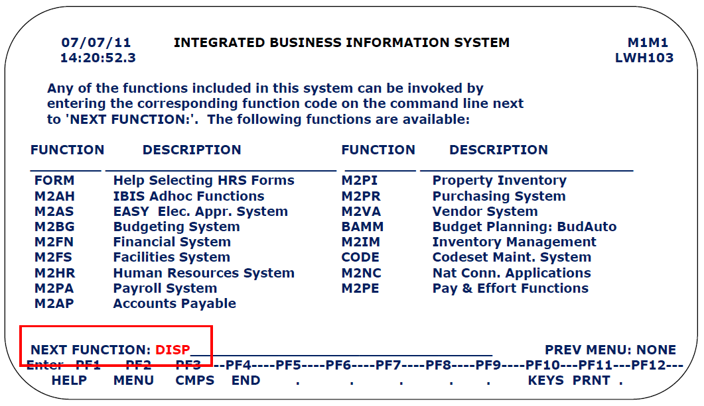
- Press Enter.
- A blank DISP form will appear on the screen.

- The DISP form contains 3 screens for entering information and a final screen for submitting the form.
- Complete all 3 screens and submit the form. Partially completed forms cannot be processed.

Completing DISP Form - Screen 1 of 3:
Complete all fields that apply to the tangible assets for disposition or transfer. Description of fields follows the screen shot.
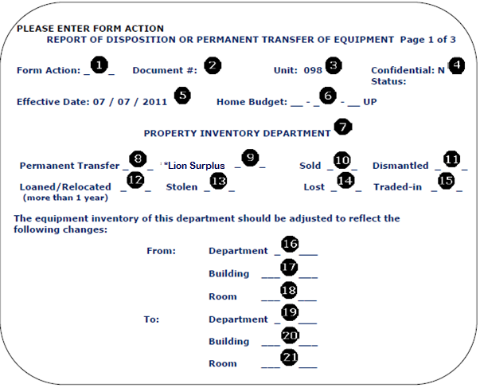
Form Action: Type ADD.
Document Number: Do not type in this field. Number is auto filled when form is saved.
Note: This is the reference number for this form. Use this reference number when referring to this form in communications.
Unit: Admin Area is auto filled based on user accessing the form.
Confidential: defaults to No - cannot be modified.
Effective Date: Auto filled by the system.
Home Budget: Enter Budget number in IBIS format. UP autofills, but can be overwritten when needed.
Example: Home Budget 224-01 HY would be entered as 02-024-01 HY.
Disposition Action Section: For items # 8 - # 15 place an X on the underlined space following the correct disposition action for the tangible assets. For help selecting the correct action go to Disposition Actions.
Permanent Transfer: Select if transfer is permanent. Items with inventory tags must be reported for permanent transfer.
Lion Surplus: Select if asset will physically be moved to the Lion Surplus to be sold there.
All items going to Lion Surplus must be reported. Items may or may not have an inventory tag.
Note: Credit will be forwarded to the Administrative Area name and Budget number fields on the second screen of the DISP form. Be sure to fill the information into the fields. Do not leave blank.
Note: If purchasing item, check must be payable to The Pennsylvania State University and mailed directly to:
Lion Surplus
The Pennsylvania State University
Services Road
University Park, PA 16802
Sold: Select if item will be sold within the department. (If an IDCC is utilized, please place Disposition Form number on IDCC.) Item may or may not be physically moved to Lion Surplus for the sale. All items to be sold must be reported. Items may or may not have an inventory tag.
Dismantled: Select if item will be dismantled and/or cannibalized. Items with inventory tags must be reported as dismantled.
Loaned /Relocated (for more than 1 year): Select if item will be loaned or relocated for more than 1 year. Only items with inventory tags must be reported for relocation.
Stolen: Select if item was stolen. Only items with inventory tags must be reported as stolen.
Lost: Select if item was lost. Only items with inventory tags must be reported as lost.
Traded-in: Select for item that is traded-in for another item. Only items with inventory tags must be reported as traded–in.
Note: For the disposition of tangible assets that are traded-in on new purchases, the document number of the DISP should be indicated in a statement in the Note Pad area of e-Buy+ for the new asset.
From: Department - enter the department name where the tangible asset is located.
From: Building - enter the building name where the tangible asset is located.
From: Room - enter the room number where the tangible asset is located.
To: Department - enter the department name where the tangible asset is being moved.
Note: If the tangible asset is being transferred to Lion Surplus, do not enter any information in the To Department, Building or Room.
To: Building - enter the building name where the tangible asset is being moved.
To: Room - enter the room number where the tangible asset is being moved.
Press PF8 or Page Down to go to the next screen.

Completing DISP Screen 2 of 3

Screen 2 Overview:
- This screen allows for entry of up to 10 items.
- If more than 10 items are to be disposed of or transferred an MS Excel spreadsheet listing any number of items can be created and e-mailed to Property Inventory.
- The spreadsheet should reference the Document Number of this form and be laid out to include the tag number, serial number and description.
- To this screen add a note to the Article field that an items list will be e-mailed.
- E-mail message should reference the Document Number of this form.
- The 3 screens of this DISP form must be completed and submitted even if a spreadsheet of items is being e-mailed to Property Inventory.

Screen 2 Steps:
- List each tangible asset that is being disposed of or transferred on the lines provided.
- Type information into Sections 1, 2, 3, 5 and 6.
- Leave Section 4 blank. It is for Property Inventory's use.

Field descriptions follow the form screen shot below.
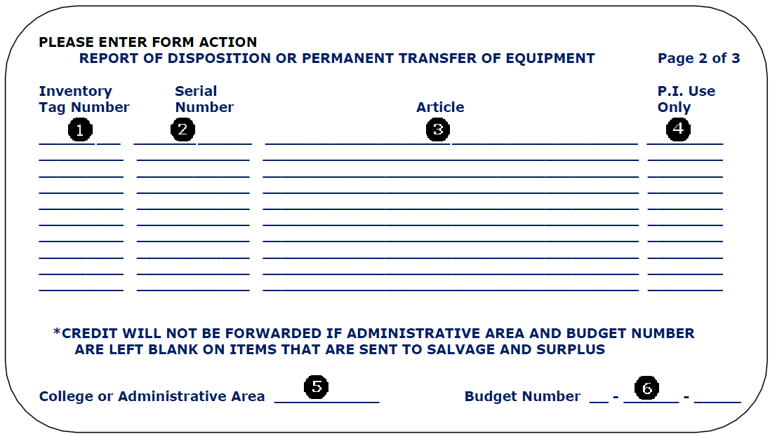
Inventory Tag Number: Enter the PSU Inventory Tag number. This is an 8 digit number. See examples here.
Note: If no PSU Inventory Tag number is available enter a zero.
Serial Number: Enter the item's serial number, if applicable.
Article: Enter a complete description of the asset.
Note: Avoid using Miscellaneous Items as the description. Carefully check for inventory tag numbers on each item being reported. Items with inventory tags must be listed separately in the IBIS form or the spreadsheet. Items without an inventory tag should include the serial number and a description whenever possible.
P.I. Use Only: Leave blank. This field is for Property Inventory Use Only.
College or Administrative Area: Enter Administrative Area to be credited for items being sent to Lion Surplus. May or may not be the same Admin Area listed in screen 1. DO NOT LEAVE BLANK.
Budget Number: Enter Budget Number to be credited for items being sent to Lion Surplus. May or may not be the same budget listed in screen 1. Enter Budget number in IBIS format. DO NOT LEAVE BLANK.
Example: Budget 224-01 HY would be entered as 02-024-01 HY.
Press PF8 or Page Down to go to the next screen.

Completing DISP Screen 3 of 3
Field descriptions follow the form screen shot.
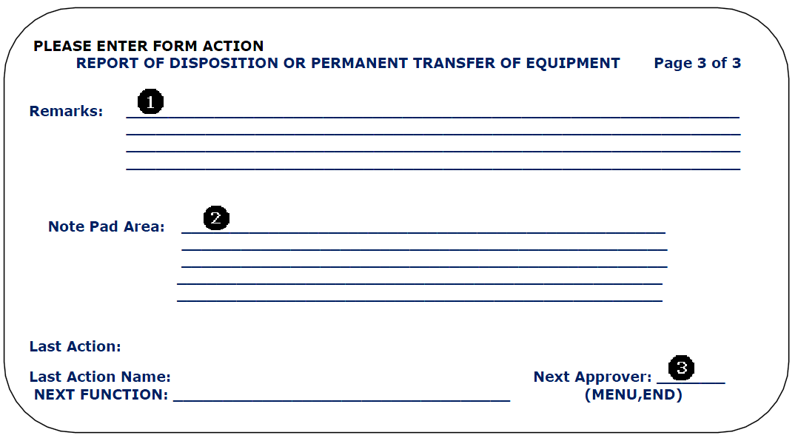
Remarks: Enter any additional information that is pertinent to the disposition or transfer of the tangible asset(s). Include details that may expedite the processing of the form.
Note Pad: Do not use this area unless all pertinent information could not be fit into the Remarks section above. DO NOT repeat already entered information. MAY BE BLANK.
Next Approver: Only to be used when the next approver is not the default approver on the approval path. Enter the User ID if an off path approver is to be first approval. Field may be blank.
Press PF12 to ADD (save) the entered information.
Information is now saved. The next step is to submit the form for approval.

Completing DISP Form Final Screen:
In the final screen the DISP form is submitted. Form must be submitted for approval.
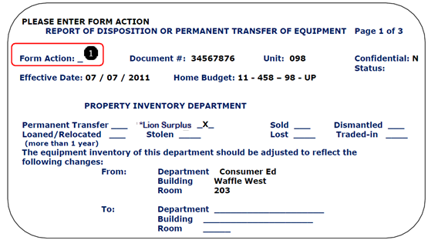

Submit Form:
- Type SUB in the Form Action field ( above).
- Press PF12 to submit the form for approval.
- Form is now submitted for approval.

Approval Process:
- When submitted the DISP form will start through the approval process set up by the FO for tangible assets in the administrative area.
- For more details on the approval process contact the FO office in your administrative area.

Notes on Time Frame:
- The DISP form does not reach Property Inventory for processing until the administrative area approval process is complete.
- Approval Process can take up to a week or longer depending on the availability of approvers.
- Property Inventory processing can take up to 3 business days.
- Lion Surplus pickup time is approximately 2 – 3 weeks. (depending on the time of year)

Additional Notes:
- Surplus and scrap tangible assets may be sold by the Lion Surplus Department. Upon receipt of the DISP form, Property Inventory will notify the Lion Surplus.
- Budgets are credited twice a year for the sales at Lion Surplus (see Policy BS15).
- If the equipment to be disposed of has a US Military tag, US Government tag, PSU Sponsor tag or PSU Government tag the item must be approved by the appropriate department (Property Inventory and customer) prior to the item being sent to Lion Surplus.
- Items with hazardous or radioactive stickers must be cleared by the Environmental Health and Safety department prior to notifying Lion Surplus.
- Relocations of tangible assets expected to last from 30 days up to and including one year are to be reported on the Report of Temporary Relocation of Tangible Assets.
- Relocations of tangible assets for less than 30 days, such as moving furniture and office machines to another area during student registration, need not be reported.
- Relocations of tangible assets to a non-University location for the purpose of conducting University business must be approved through the Request for Authorization to Use University Tangible Assets at a Non-University Location form.

Disposition
Disposition of a tangible asset could include any of the following actions:
- Asset will be permanently transferred to another* admin area, building, room number, or custodian
- Asset will be sent to Lion Surplus.
- Asset will be sold to an employee* (may or may not physically move the asset to Lion Surplus)
- Asset will be or was dismantled and/or cannibalized.
- Asset will be loaned or relocated to another admin area, building, room number, or custodian.
- Asset was stolen or lost.
- Asset was traded in on a new asset.
- Assets sold to another university when a faculty member leaves.
- Government or Sponsor property being returned to customer.

*When faculty/research person leaves PSU, permission (approvers may be; College Dean, Risk Management, Property Inventory and Lion Surplus) must be granted for the disposition of any tangible assets to new location.

Note: To use university tangible assets at a non-university location the following form must be utilized:
Request for Authorization to Use University Tangible Assets at a Non-University Location form.
Back to Introduction or Back to Screen 1 Instructions

Tangible Asset
A Tangible Asset is equipment both moveable and fixed. Equipment can be: Instructional, Research, Computer related, Furniture, Vehicles, Appliances, Museum Items, Machinery or Telecommunications.

Equipment can be:
- Capital Equipment: The equipment has a value of $5,000 or more. The equipment has a useful life of two (2) or more years.
- Non-Capital Equipment: The equipment has a value of less than $5000.
- Tagged Equipment: Capital acquisitions are assigned a bar-coded tag, the number is used to identify that item. The tag is 8 numbers - no letters or symbols.
- Not Tagged Equipment: Acquisitions which cannot be tagged, such as paintings or radioactive
Inventory equipment, are assigned an item number and a special condition code when entered on the computer data base. For the purpose of inventorying, "untagged" items are included on the numerical listing generated by OAS and can be identified by their condition code.

Note 1: Vehicles are tangible assets and must be processed as such.
Note2: Plant Assets such as buildings, land, Improvements to Buildings (IOB) are not tangible assets.
Back

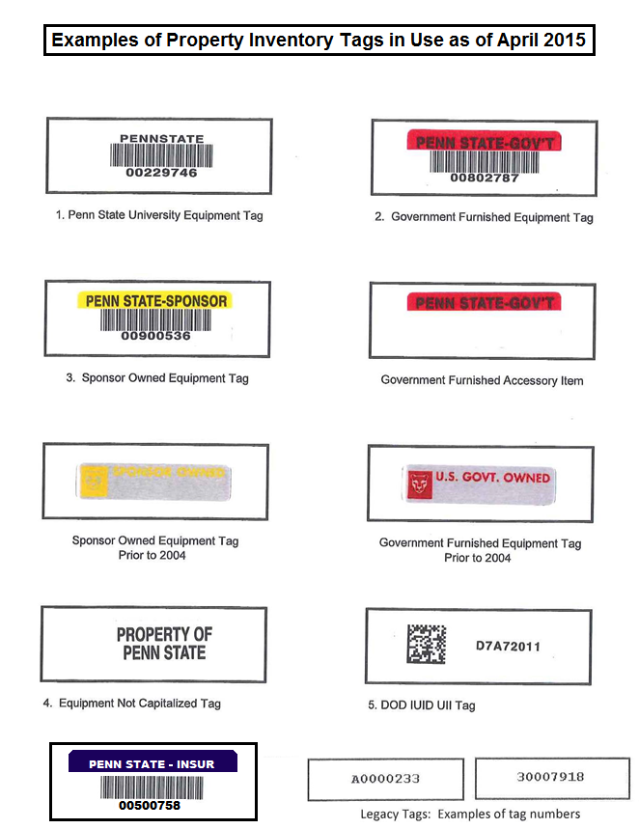

Back

