**[CaseWare Monitor Job Aid](https://casewaremonitor.fis.psu.edu/)**

**Overview:** Internal Audit, the Corporate Controller’s office, and the Financial Officer organization have embarked on a joint initiative to implement a program to continuously monitor for high-risk transactions at the University. This effort utilizes data analysis to identify transactions that may indicate possible fraud, waste, and non-compliance with University policies and other regulations and therefore require further review. We are using Caseware Monitor software to automate the data analysis and distribution of transactions identified to the responsible areas for review and/or remediation.

The initial implementation of this software is comprised of 15 analytics. Each of these analytics will generate exceptions based on anomalies in our data. When an exception is found, the remediation process follows a predefined “workflow” as displayed below. The different “states” an exception can be in are as follows: 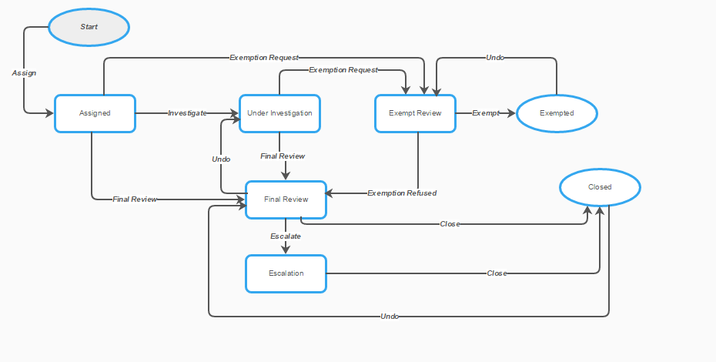

* Start: Here, an analytic has generated exceptions, but they are not assigned to anyone yet. This is the first step in our workflows, and these exceptions will appear in the “queued” area of CaseWare for assignment.
* Assigned: Here, an item is assigned to an initial reviewer to determine if it requires investigation or can be quickly resolved.
* Under Investigation: Here, an item is being investigated further through communication with others or accessing documentation.
* Final Review: In this state, an item has been investigated and a remediation is suggested. By this point, any supporting documentation has been attached and comments and indicators are added. A final reviewer (in most cases, a Financial Officer) now has the option to approve these suggestions or not.
* Exempt Review: An exception is sent to an exemption review if the investigator believes this specific exception should not be addressed again. This should be a rare case, and used only if the analytic is intrinsically wrong in how this exception was generated.
* Escalation: An exception is sent to escalation status when it is of a very serious nature and should be reviewed centrally by Internal Audit or the Controller’s Office.
* Closed**:** An exception is sent to closed status after it has been final reviewed, and any remediation, if necessary, has been documented.

**Access:** Those who have been granted a license to CaseWare monitor will gain access through Single Sign-On (SSO) authentication. Once you click on the link above, you will automatically be taken to the “thumbprint” login screen and asked to enter your Penn State credentials. Once this has been completed, an additional login screen will appear, but should quickly pass you through to the CaseWare Monitor welcome page without further authentication.

**Dashboard:** Your default ‘home page’ in CaseWare is your dashboard. This page quickly displays how many items are in your queue, notifications, work items, and a customizable favorites section. In the “My Work Items” panel on your dashboard, you can see a linked count of the work items that are open, overdue, watched, queued, and closed. Each one of these numbers is linked and can be used to access these quickly and directly.

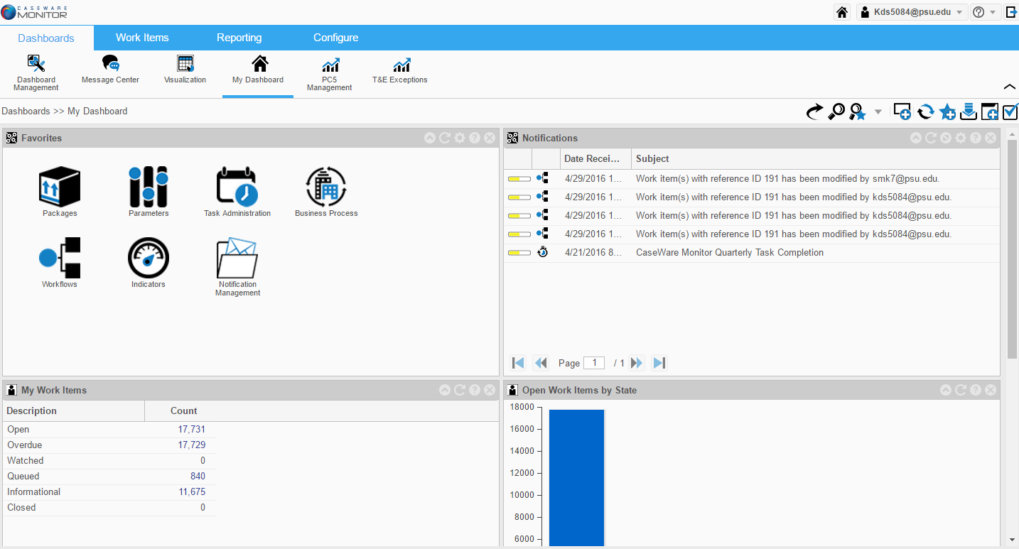

Any time an exception is assigned to a role, the exception is placed in a “queue”. **The only way users can view what is sitting in a role that they are assigned to is to view the “queued” items from the dashboard.** If your home page is not your dashboard, please follow the below steps to make the dashboard your home page.

1. Select the drop down arrow next to your userid in the top right hand section of the screen. Select “User Settings”.

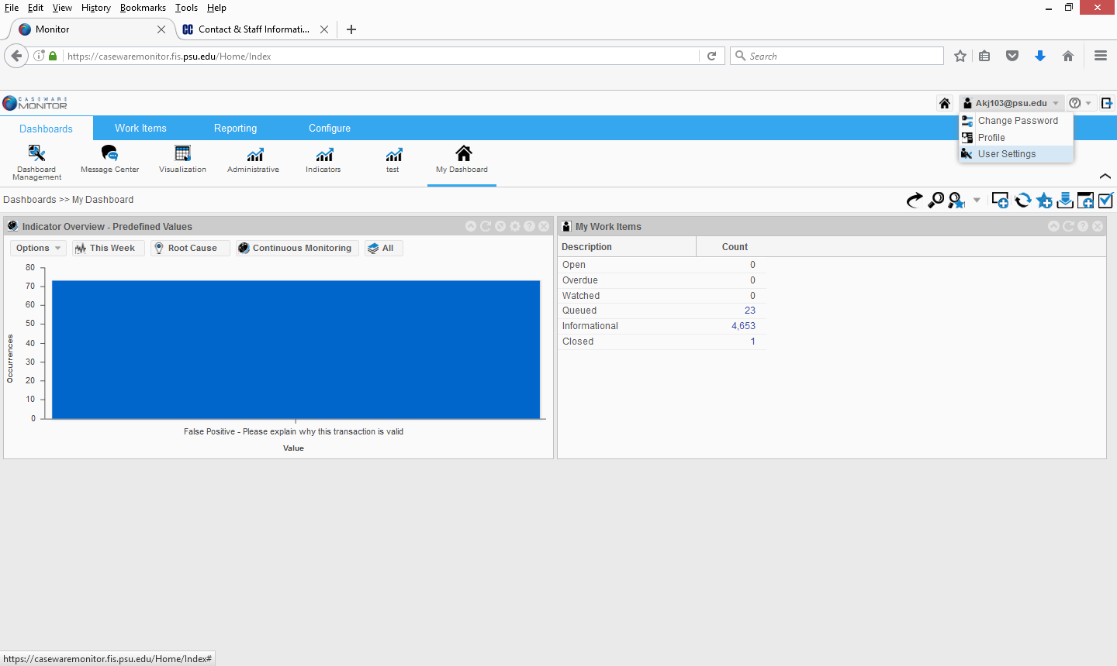

1. **A pop-up box should appear. Ensure “Dashboards” is selected as the “Page Type” and “My Dashboard is selected as the “Page Item”. Select Save.**

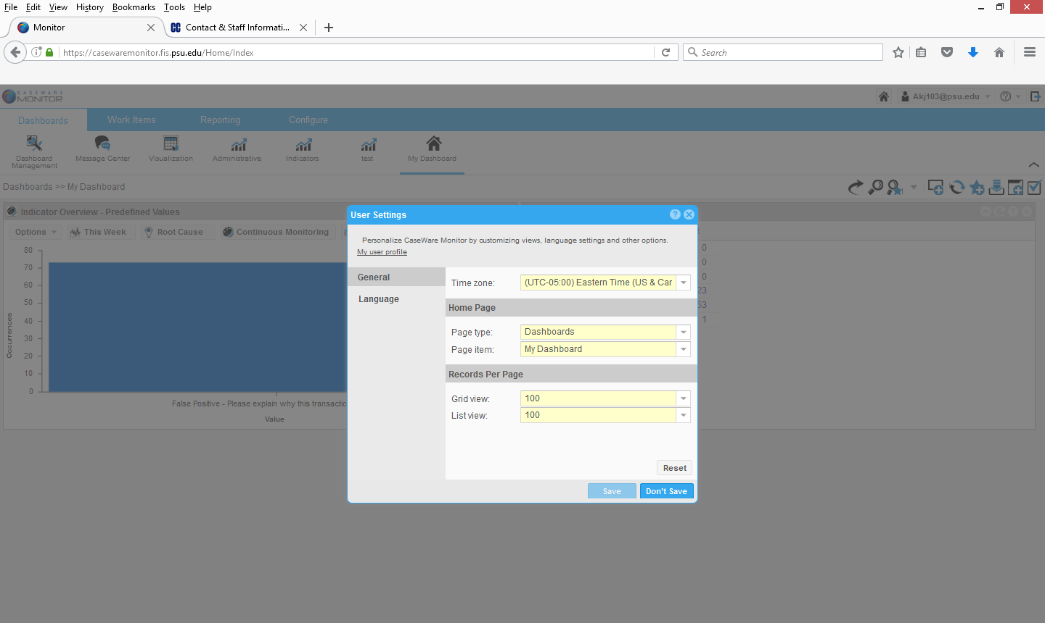

**Remediation:** When an analytic is run in the system, the exceptions generated will appear in your ‘Queued’ section reported on your dashboard tab. Clicking on this number will bring you to your work items tab. In the left-hand section, you can see all analytics for which you have exceptions. A unique “Work Item” ID number is assigned to each exception, and can be used to reference specific items in CaseWare. Clicking on one will bring up only exceptions from that analytic. If you would like to see all exceptions assigned to you, click “All Items” at the top of this section.

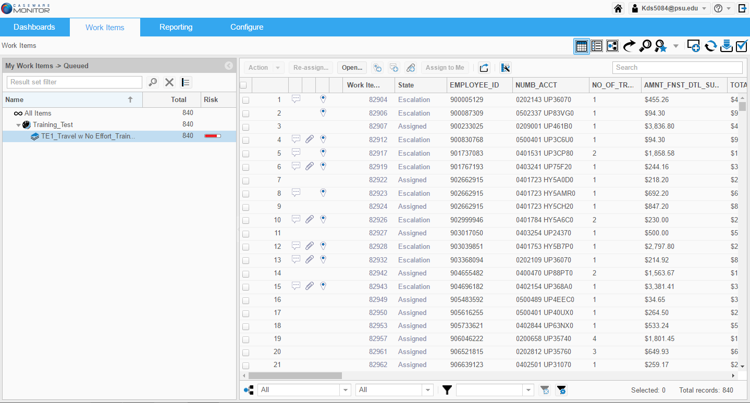

To **filter** on one of the columns, you can hover over the column heading and select the down arrow to open options. From here, you can sort, edit which columns are displayed, or edit filters.

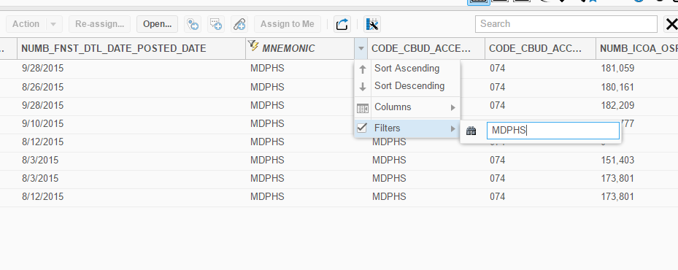

If you are interested in advanced query building and saving, these options can be found at the bottom of the page. For more information, you may contact your Financial Officer, or a business process administrator.

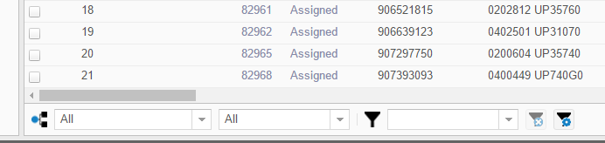

To **Export** multiple exceptions to Excel, select the items in which you are interested and click the export icon export icon. This will open an Export dialogue box where you can chose a file name and type as well as which items to export (All, Selected, or Pages.)

To enter the ‘detail’ view of an item (shown below) you can either select an item with the checkbox in its first column then click “Open,” or double click on the item.

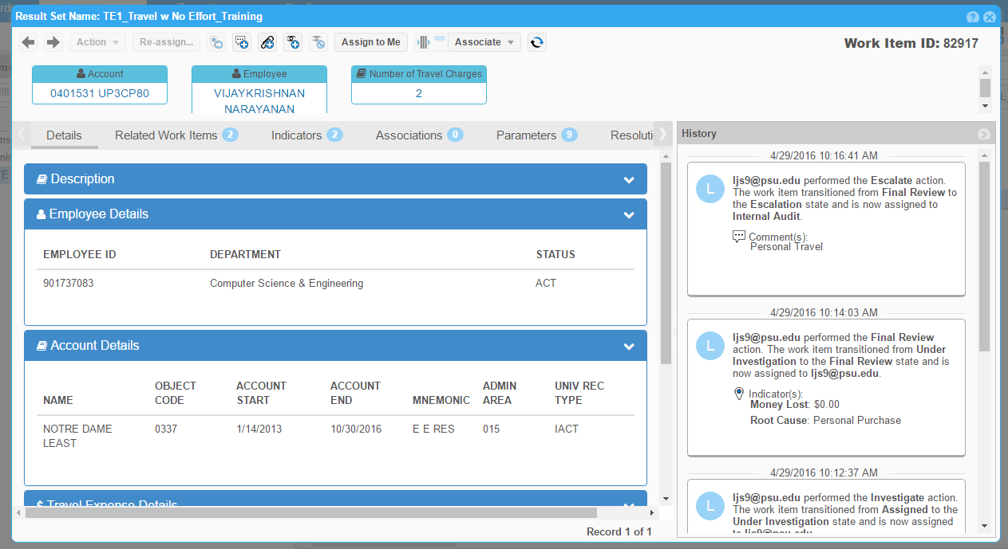

Opening the “Description” bar (below) will give information driving the analytic, such as the criteria string and data sources

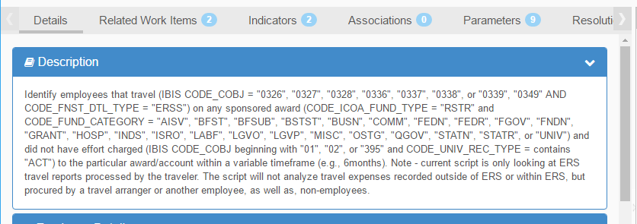

The bars below this show specific details about the exception such as Employee ID, amount of a transaction, account numbers, mnemonic, etc.

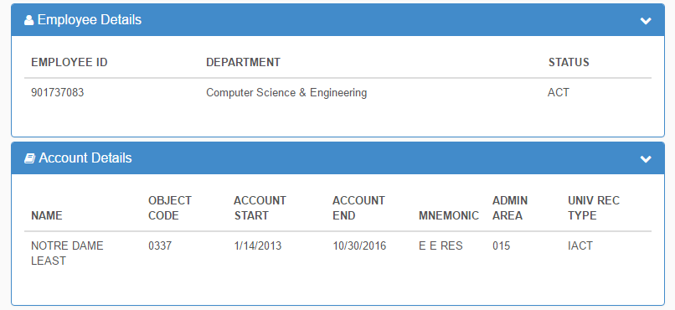

If there are multiple transactions related to an exception, these details will appear in the “Related Work Items” tab. 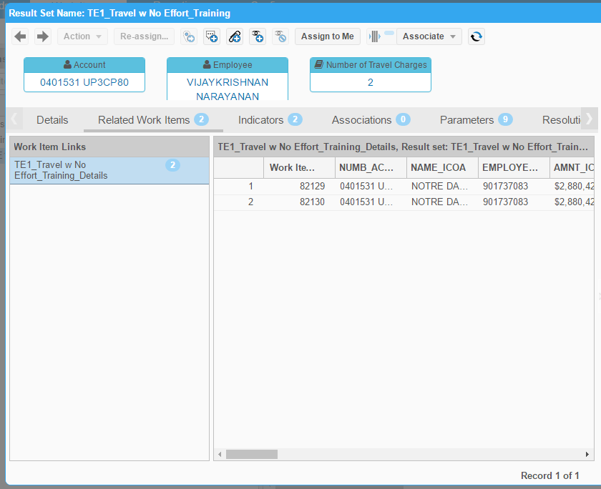

If you are unsure what steps to take to investigate and resolve an issue, click on the “Resolution Guidelines” tab for suggested steps as seen below.

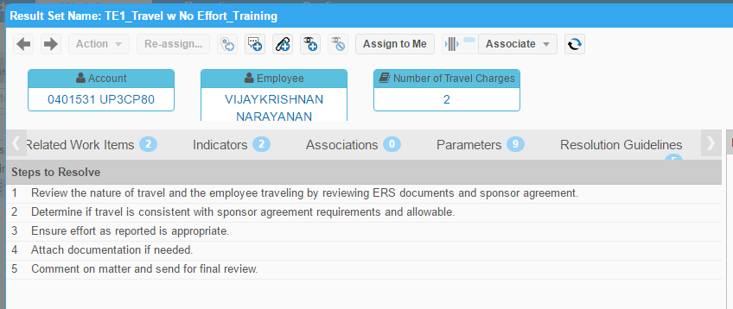

To take any actions on an item, there are a number of icons at the top of this detail view. Many of these buttons are also available in the work items list view so that you can take action on multiple items at once (i.e. assign many items to yourself in one action.)

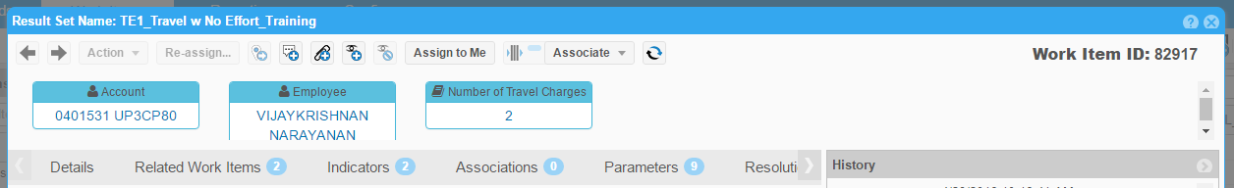

* The right and left arrow buttons icons allow you to move between different exceptions if you chose to open multiple through the use of select boxes.
* The action and reassign buttonsicons allow you to move an exception to a different state in the workflow.
* The add indicators, comments and attachments buttonsicons allow you to add indicators, comments, and attachments *before* moving an exception to another state.
* The watch option buttons add and remove exceptions buttons allow you to add or remove an exception from your watch list. Items in your watch list will appear on your dashboard and send you notifications every time an action is taken.
* The assign to me button icon can be pressed to move an exception from the queue to your open assigned items.
* The go to new assigned open items icon will take you directly to your newly assigned open items if working in a list.

When taking an action on an item, you are asked to provide details in an “Action Work Items” dialogue box (below.) The first 4 fields are information about what action is being taken and where the exception is being sent next. Any field highlighted in pale yellow is a required field, and CaseWare will not allow you to save an item until it is completed. You will have to expand sections to be able to fill out this entire box (e.g. Predefined comments, Attachments, and Indicators)

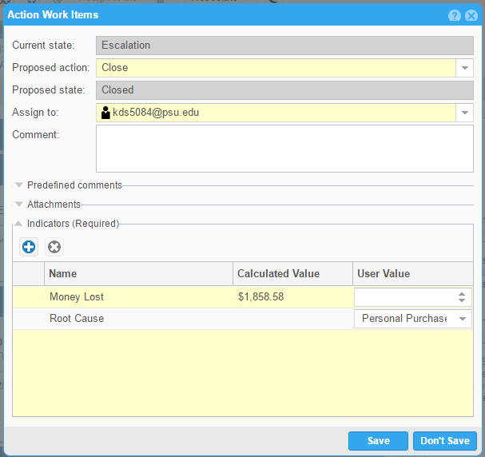

The “History” section displays all actions taken on a particular exception, including attachments, comments, and indicators. Attachments can be viewed by clicking on their name beside the paperclip symbol.

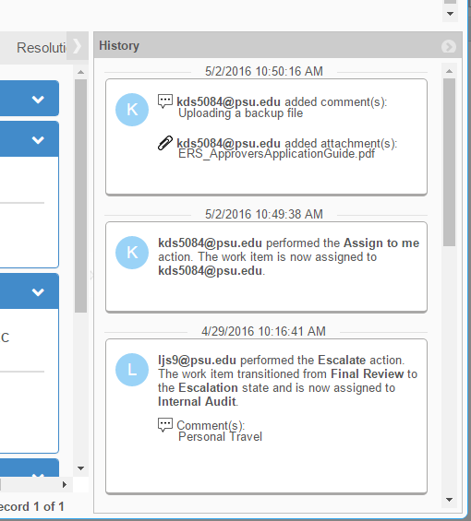

**Queries and Saved Searches:** CaseWare Monitor includes the option to perform custom queries and save favorite searches for frequent use. Click on the ‘search’ button: 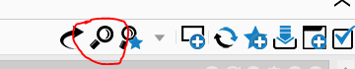

Once in the Search screen, add a new search with the plus button in the upper left-hand corner Once in the Search screen, add a new search with the plus button in the upper left-hand corner 

Once you’ve named your search and saved it, you can start adding criteria to the query. This is done by using the ?+ button (circled in red in the screenshot).

Add a new line for each criteria necessary. The most common query you’ll need is one to show open items assigned to a combination of individuals and roles. This example is provided in the screenshots below. When you’re finished creating your query, make sure to click the save button (circled in blue in the screenshot). You can run your query at any time with the run button (circled in black in the screenshot). Results will be displayed in the box below the query, and can be opened and exported directly from this view. After your search is saved, you can come back to it at any time by entering the search screen and double clicking the saved search on the left. *System limitation: Each query is limited to 6 rows of code. Thus, you may need to design two or three queries to ensure you can view all of your open items.*

**Open Items by Remediator Example**

The below query will search for open items that the remediator should be working on.  You have to search by individual user id, as well as the campus/college remediator role because items could be sitting in the campus/college queue or the individual’s open items.

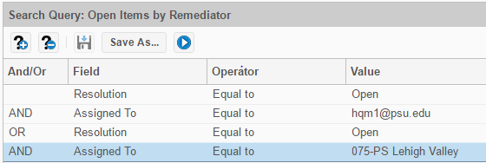

**Open Items by Approver Example**

The below query will search for open items that the Financial Officer should be working on.  You have to search by individual user id of the Finanical Officer/approver, as well as the campus FO role because items could be sitting in the FO queue or the individual’s open items.

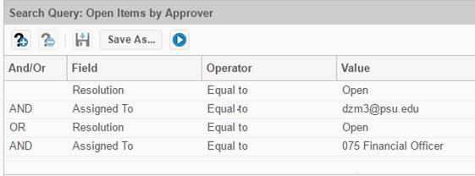

**Help:** Should you ever not know what to do on a particular screen, find the help button at the top right corner of that screen: Question Mark Button. This will direct you to a help topic *specific* to this particular screen or action with descriptions and instructions. If you are still unsure of what to do, contact your Financial Officer.